Flutter Module – 6 –
Introduction
1. Display This Information using print
•Your Name
•Your Birth date
•Your Age
•Your Address
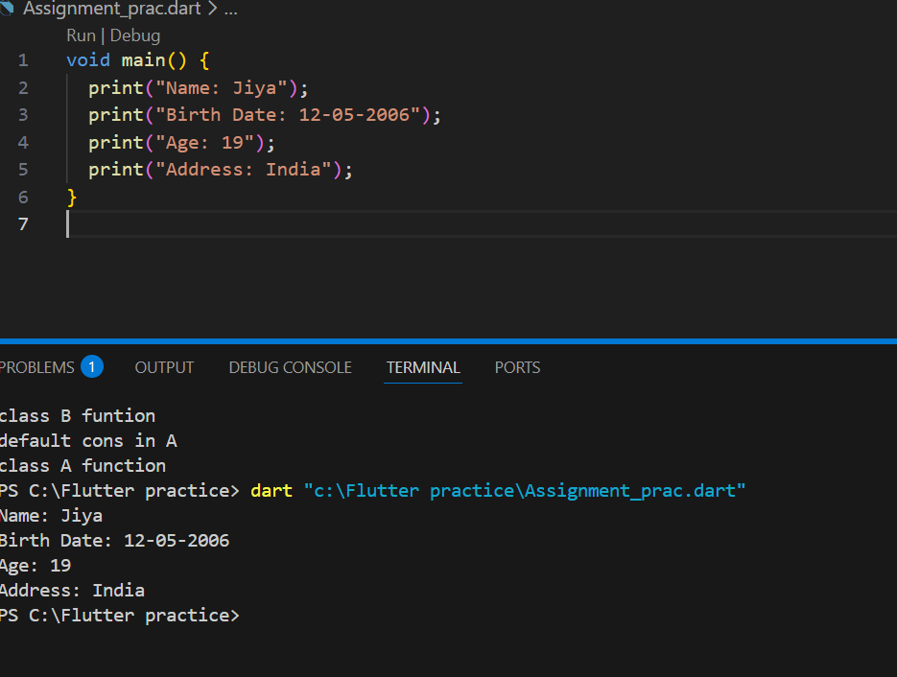
2. Write a program to make addition, Subtraction,
Multiplication andDivision of Two Numbers.
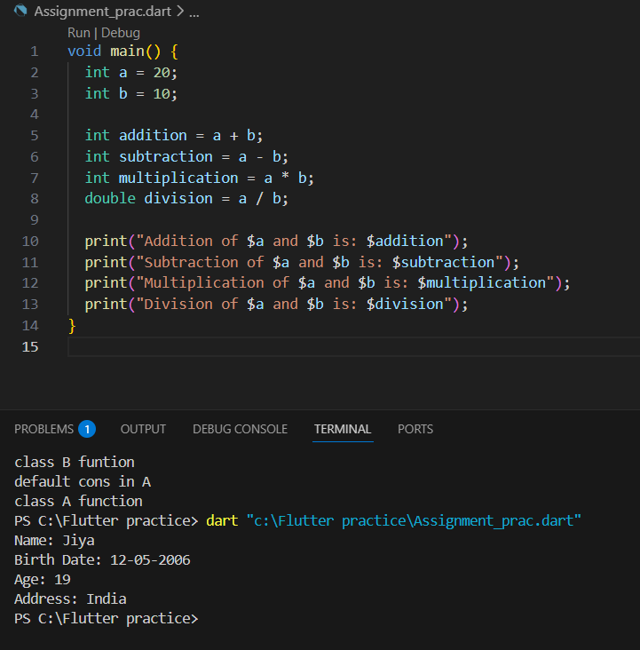
3. Write a program to make a square and cube of number.
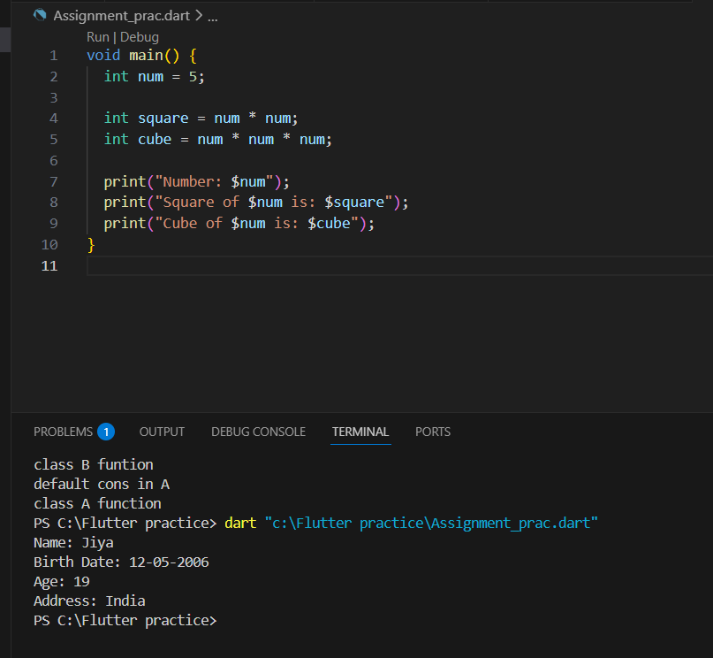
4. Write a program to find the Area of Circle
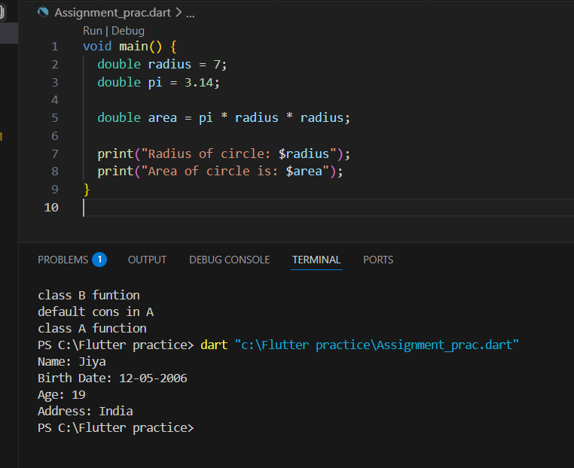
5. Write a program to find the Area of Triangle
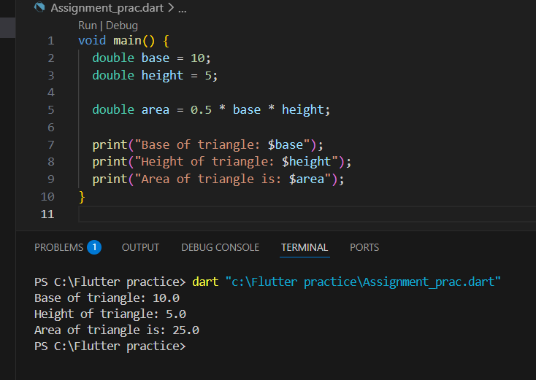
6. Write a program to find the simple Interest.
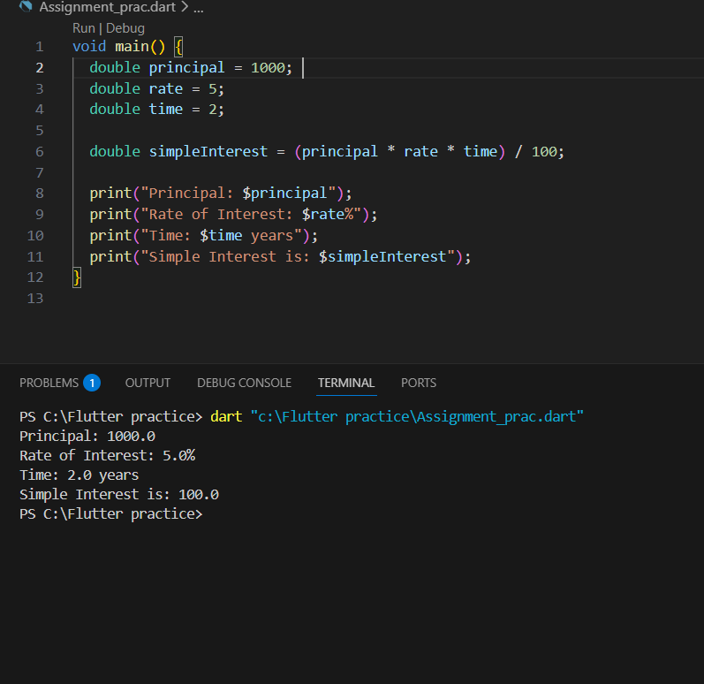

7. Write a program to convert temperature from degree
centigrade to Fahrenheit.
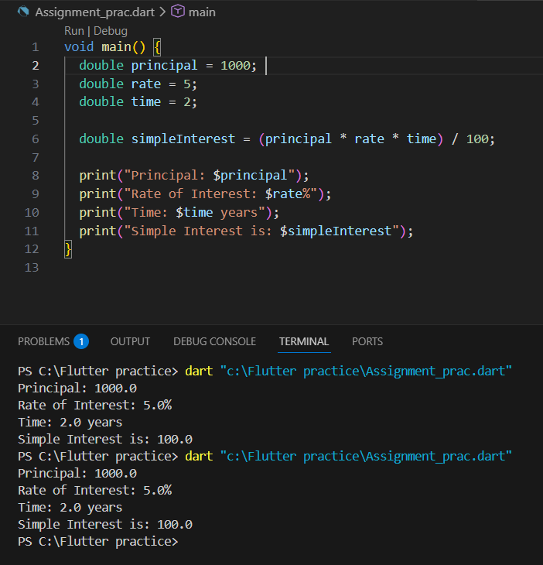
8. Write a program to calculate sum of 5 subjects
& find thepercentage. Subject marks entered
byuser.
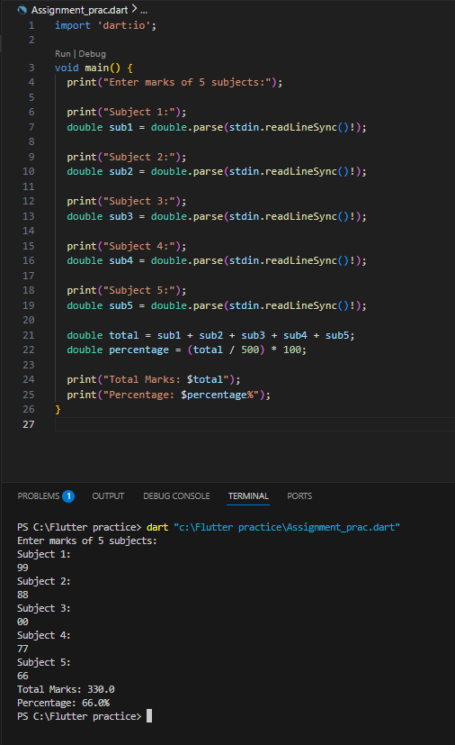
9. Write a Program to show swap of two No's without using third
variable.
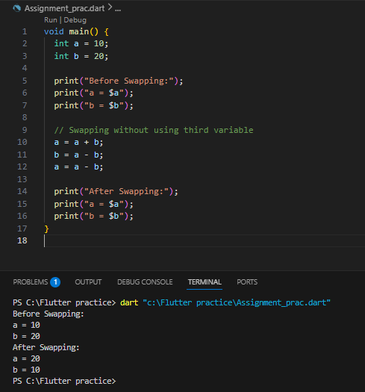
10. Write a Program to check the given number is Positive,
Negative.
